How to register for the veterinary academy simulation center (VASC)

- Click the link bellow:

https://lsmu.lt/en/about-lsmu/structure/general-departments-of-the-university/academic-departments/veterinary-academy-simulation-centre/

- In the window that opens, select Simulation classroom .
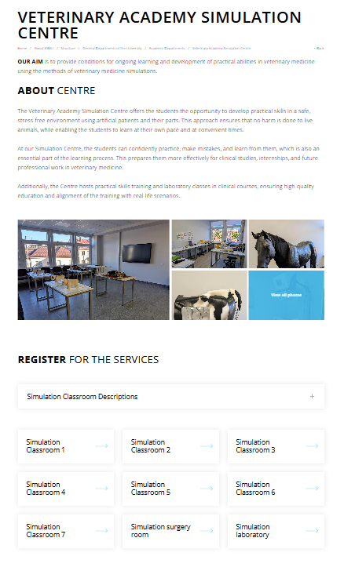
- In the next window, select the station.
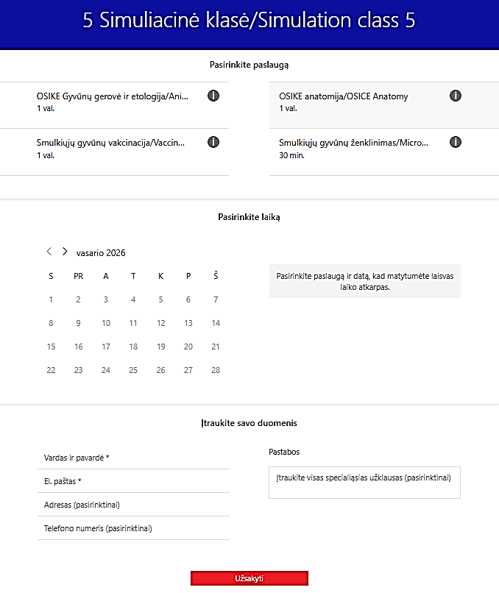

- After clicking on the station “Small animal microchiping/Identification”, a new window will open. There you must choose an available active date and time and enter your personal details. Once all required information has been completed, click Book.
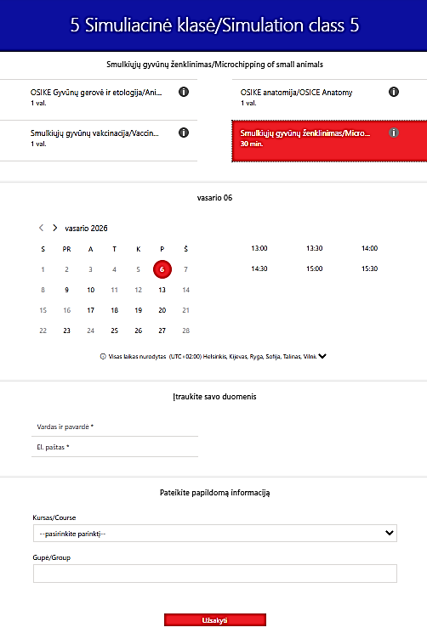
BOOK
- If the registration is completed correctly, you will receive a confirmation email.
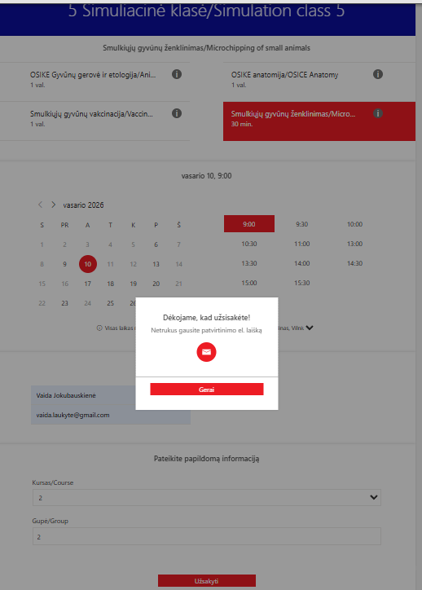

- To cancel or reschedule your registration, open the confirmation email you received and click Reschedule.
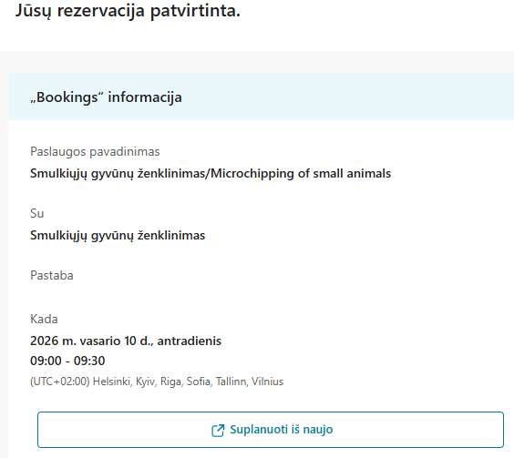
- A new window will open where you can cancel your registration or plan a new one.
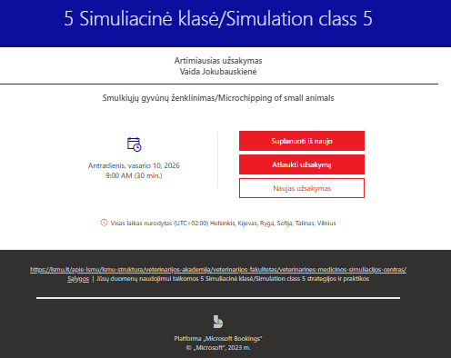

- Please note that registration for a selected station is closed 24 hours before the scheduled time.
If 24 hours or less remain before the selected time, registration is no longer possible.
Cancellation of a registration is also only possible no later than 24 hours before the scheduled visit.
If cancellation is required later than this time, please inform the VASC staff by email that you will not be able to attend.

Contact details:
Agne.belecke@lsmu.lt
Karolina.jankauskaite@lsmu.lt
Vaida.jokubauskiene@lsmu.lt

- When arriving at the Simulation Centre, students must have a lab coat and indoor footwear (slippers or other indoor shoes).
- Students wearing outdoor shoes or without a lab coat are not permitted to enter VASC.
- You may change clothes and store your personal belongings in the changing room, which is located immediately to the left after entering VASC.
- Once ready for work, please go to the staff office and inform the VASC staff of your arrival. A staff member will then escort you to your reserved simulation station.
- If you have any questions or uncertainties, you may always ask the VASC staff for assistance.
- VASC also has a rest room, where you may rest, heat your food, or wait if you arrive earlier than your scheduled time.

