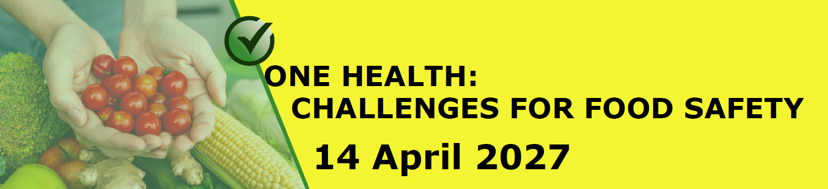
Abstract title - word limit is 15. Title in Times New Roman, Font Size 14, Bold, Centered, Single Spaced, Starting Each Word with Capital Letter.
Presenting Author – Name (In Times New Roman, Font Size 12), affiliation. Co-Authors - Name (In Times New Roman, Font Size 12), affiliation.
¹ Affiliation, e-mail address (In Times New Roman, Font Size 10) (this person must be listed as the first author)
² Affiliation, e-mail address (In Times New Roman, Font Size 10).
Corresponding author:

Oral (12 min + min for discussion) and poster presentations (5 min) are welcome. The main text of abstract should be written in English and should be in Times New Roman, Font size 12, single line spacing, no spacing before and after paragraph, justified. The Presenting Author must submit the abstract and is required to be the corresponding author for that abstract. The abstract should be typewritten for A4 format paper (210 × 297 mm). Times New Roman font. Top and bottom margins should be set to 2.5 cm, left and right margins to 2 cm. Single-line. Abstract should not exceed 250 words (word limit excludes: title, authors and affiliations). No figures, no tables should be included in the abstract. Do not add headers or footers. Do not add footnotes or comments. Check grammar and spelling prior to submitting. Save as a word file. Do not upload in PDF format. Please rename file as Surname_Name_2027.doc(x) for quick identification. Send your abstract as an attached file to food.safety@lsmu.lt by March 5, 2027.

Keywords: Times New Roman, font size 12, separated by commas, lowercase.

Check the box for the type of presentation:
☐ Oral presentation (15 min) | ☐ Poster presentation (5 min)

